PAMF PROMS TJR / EDC Conversion

Technical Specifications V1

Lehman, Michael

2017

# OVERVIEW

Palo Alto Medical Foundation (PAMF) Orthopedic Clinics now employ a Patient Reported Outcomes Measurement System (PROMS) to administer a series of questionnaires to patients who undertake a Total Joint Replacement (TJR) surgery procedure for a hip or knee. This PROMS EDC has been in piloted production in in two locations since late July 2017.

**We seek to implement a EDC questionnaire conversion for PAMF PROMS, from the current vendor-hosted questionnaire platform to the Sutter RDD “Maestro” software platform.**

**The plan is to implement this EDC conversion quickly, by the end of November, and in a manner that has no adverse impact on the patient EDC experience**. Indeed, it’s critically important that a patient completing a survey on the prior external platform and the new EDC platform be equally satisfied with the experience, by virtue of an *equivalent look and feel and function* (e.g., skip logic, error checking, progress bar, etc.). None of the equivalent aspects are unique to the prior platform; rather, it represents desired EDC best practice.

The Questionnaire is one of five major components of the PAMF PROMS system. The Sutter RDD tech team will be responsible for defining and implementing the “hook up” of the EDC Questionnaire component to the other workflow components.

**Workflow – Where the EDC Patient Questionnaire Fits**

|  |  |  |  |  |
| --- | --- | --- | --- | --- |
| **Registry** | **EDC: Patient Questionnaires** | **Operational**  **Dashboard** | **Patient Detail and**  **POC Visualization** | **Data Reporting and Analytics** |
| Identify and Add a Patient | Administer the proper Questionnaire to a Patient | Show Patient Status to manage workflow activity | View scores and Qst responses at the Point of Care |  |
| **< ---------- Maestro Middleware Software ---------- >** | | | | |
|  | * Data stored in Maestro * The proper Qst to send is driven by Maestro workflow rules |  |  |  |

# GENERAL REQUIREMENTS

**Programming Approach:**

Raj review with Viraj

HTTML? JS?

Base on Biobank/Grail EDC framework? Or neuroshare?

**Supported Devices and Browsers:**

* Must function well on major browsers including Chrome, Microsoft common browsers (IE10, IE11, and Edge), Safari, Firefox.
* Must function well on all devices: desktop, laptop, tablets, iPhones, Android phones.

**General Visual Design Requirements:**

The page layout and format need to visually match the current Questionnaire. This includes, but it not limited to, using the use of equivalent standard “best practice” design elements:

* progress bar, placed in the proper location on the screen where indicated
* page format, including the use of headers and color/shading,
* font style and size,
* layout for response scales (e.g., horizontal or vertical scale display),
* response scale spacing (e.g., evenly spaced, in alignment with header response labels),
* radio button/check-box appearance (e.g., appearance of radio buttons).

**The questionnaire needs to be a responsive design for tablets and phones.**

Open Item: Frank/Viraj, do we need to share a style guide (font types/sizes, etc)?

**General Functional Requirements:**

* **“Continue” buttons** at the bottom of the page: use a tailored square design like Biobank/Grail EDC, shown below, and rename it “**Next**”. {Confirm the Biobank Qst uses “Next”)
* There is no conditional skip logic; everyone views all questions.
* All ‘required’ questions (noted with an asterisk) must be answered; if not, display an error message indicating a question must be answered.
* All questions use radio buttons (with a single response).

**Question Error Checking and Error Messages:**

* No question requires entry of numeric values. Therefore, there is no value-range check required.
* There are two fields requiring numeric entry – Letter Code and TJR Code – checked by Maestro.
* All required questions, denoted with a * by the question, must be answered to proceed.

# Questionnaire Flow:

There are four questionnaires.

#1 and #2: The HOOS or KOOS questionnaire; a patient gets one or the other, never both.

* + - **HOOS** is given to patients with a Hip surgery. It has 6 questions.
    - **KOOS** is given to patients with a Knee surgery. It has 7 questions.

#3: The **PROMIS** Global questionnaire. It has 10 questions.

#4: The **Collaborate** questionnaire. It has 3 questions.

Here are the sets of questionnaires provided to a patient and the respective components. Patients may get a “Bundle” set of questionnaires, as well as a one-time Collaborate questionnaire.

Questionnaires follow this flow:

**The Bundle Sets**

1. The HOOS Bundle = 4 screens

**Landing Page** component 🡪 HOOS component🡪 **PROMIS** component🡪 **Thank You Page** component

1. The KOOS Bundle = 4 screens

**Landing Page** component 🡪 **KOOS** component🡪 **PROMIS** component🡪 **Thank You Page** component

(same as HOOS Bundle) (**different**) (same as HOOS Bundle) (same as HOOS Bundle)

**The Collaborate Stand-Alone Questionnaire**

The **Collaborate** Questionnaire component

# QUERY PARAMETERS USED TO DISPLAY DYNAMIC

Query parameters that help displaying dynamic content on the pages and these parameters need to be passed back when submitting the data back.

c1=10695&c2=pre_op&c3=LEFT_HIP&c4=clinic&c5=Johnson&c6=Sutter&c7=John%20V.%20Lannin,%20M.D.&c8=http://dcdlrhr901:8989/pamf-proms-orchestrator/api/external/provider-pic/3096&c9=Orthopedic%20Surgeon&c10=http://dcdlrhr901:8989/pamf-proms-orchestrator/api/external/provider-sig/3096&c11=patient&c12=Left%20Hip&c13=PRE-OP

The parameter references on the component pages are as follows:

c1= TJR-code

c2=Bundle cycle

c3=Surgery type

c4=Channel

c5=Patient First name

c6=Patient Last name

c7=Provider name

c8=Provider Pic

c9=Provider Title

c10=Provider Signature Image

c11=Accessed By

c12=Surgery Type display name

c13=Bundle cycle display name

# QUESTIONNAIRE COMPONENTS

**Landing Page components**

**1: Letter Landing Page**

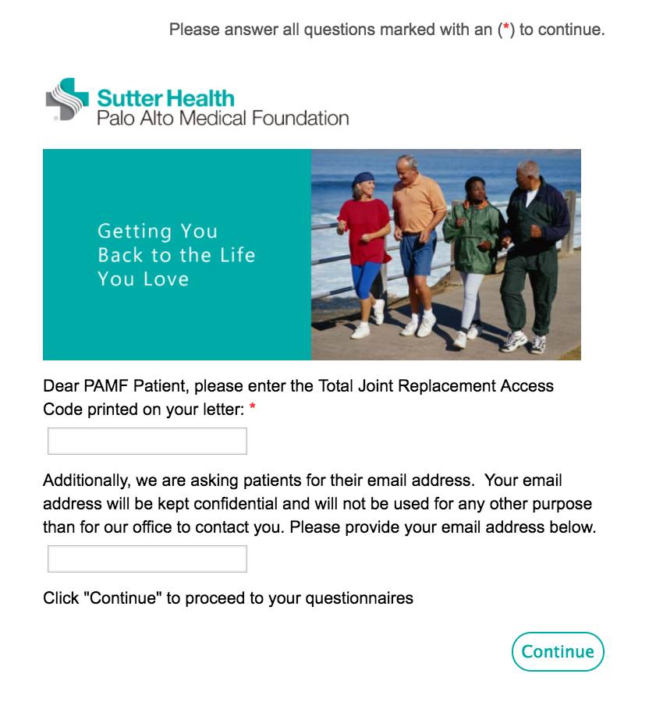

**2. Letter Landing Page, Incorrect TJR Access Code**

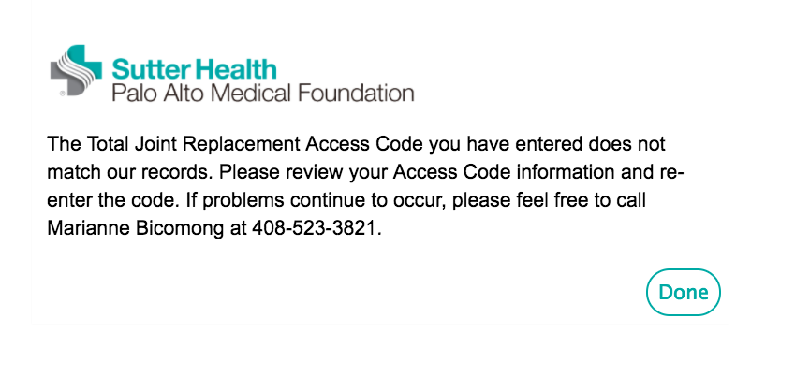

**3. Hip (HOOS) Landing Page**

Open Item: Need to provide links below (and note they are tailored to Knee)

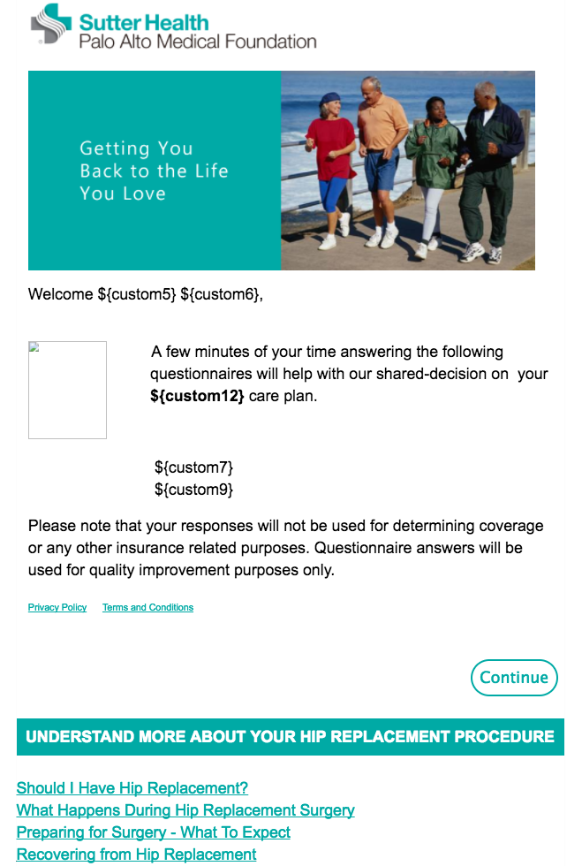

**4. Knee (KOOS) Landing Page**

Open Item: Need to provide website links below (and note they are tailored to Knee)

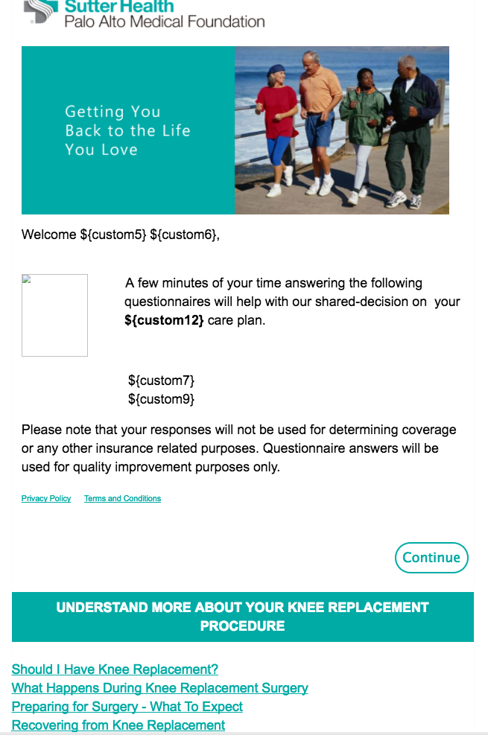

**HOOS Questionnaire component**

**5. Hip (HOOS) Intro**

**Open Item: Clarify the progress level of the “Questionnaire Progress” bar on each screen. It starts here for HOOS/KOOS Intro page. It should be placed in the upper left on each subsequent page.**

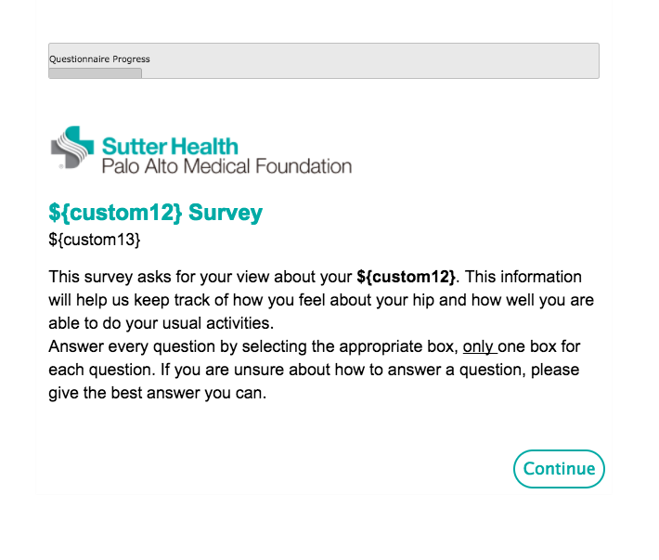

**6. HOOS Page 1 of 2 (Q1-Q2)**

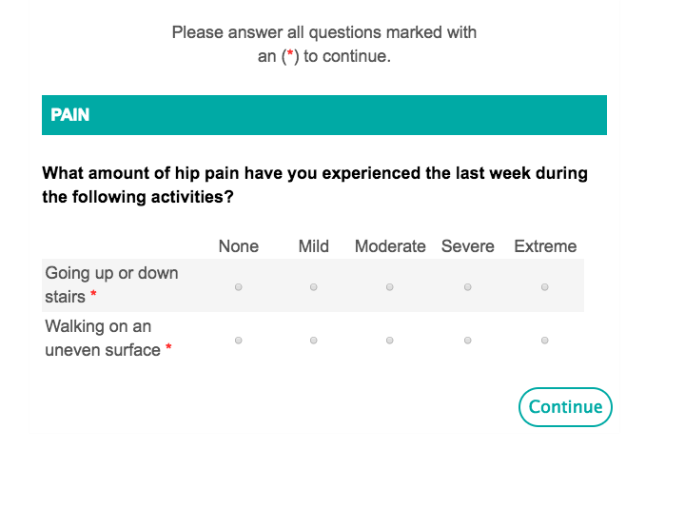

**7. HOOS Page 2 of 2 (Q3-Q6)**

**Open Item: Do we keen this page break between Q1-2 and Q3-6.**

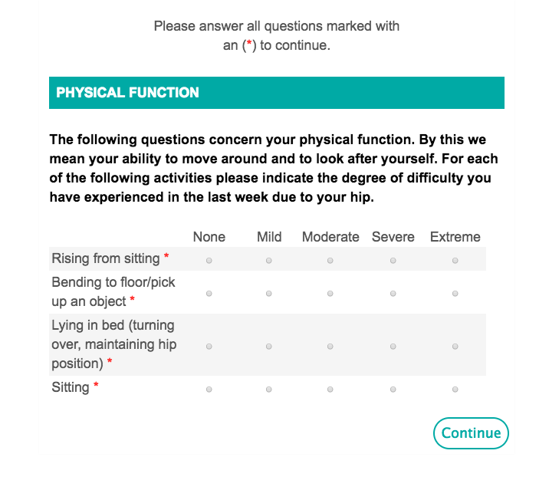

**8. HOOS Mandatory Answer Notification**

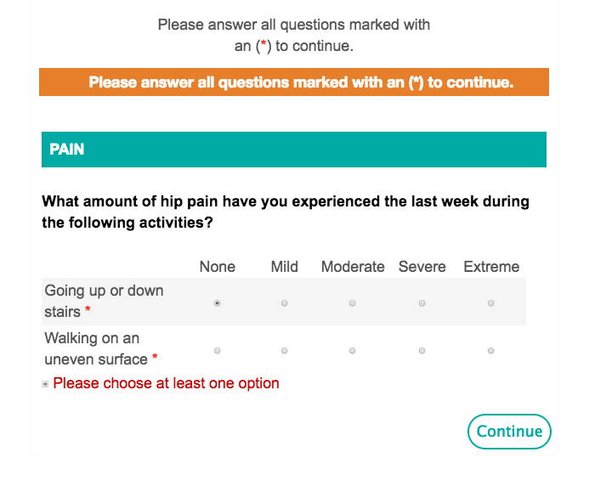

**KOOS (Knee) Questionnaire component**

**9. Knee (KOOS) Intro**

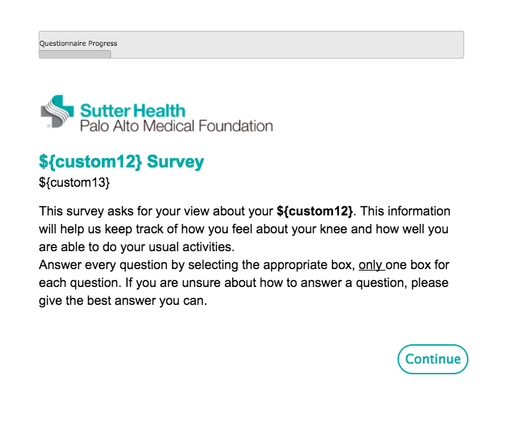

**10. KOOS Page 1 of 3 (Q1)**

**Open Item: Do we keep the 3 part page breaks.**

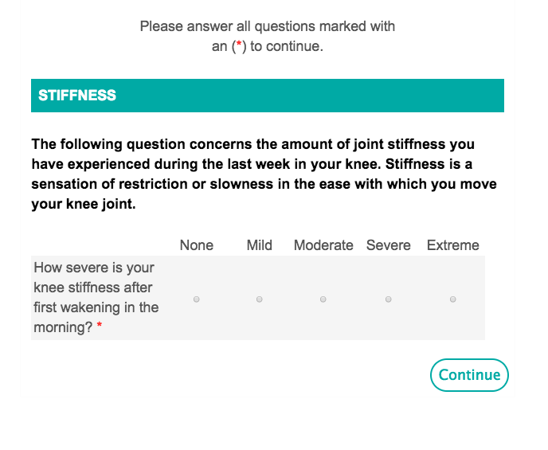

**11. KOOS Page 2 of 3 (Q2-Q5)**

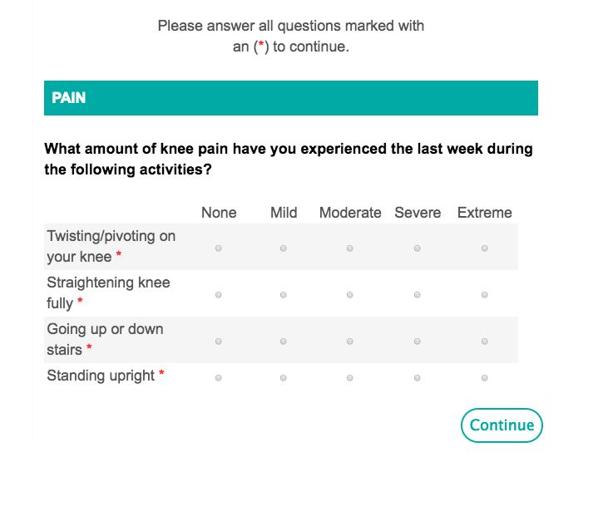

**12. KOOS Page 3 of 3 (Q6)**

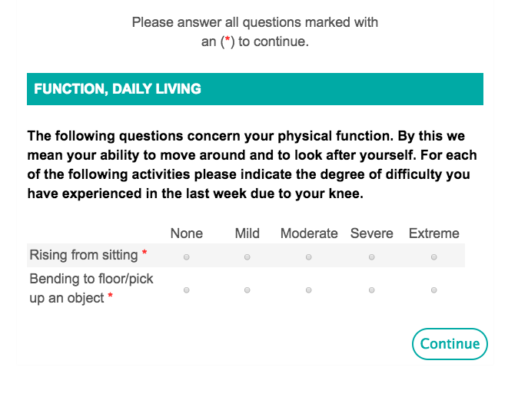

**PROMIS Questionnaire component**

**13. PROMIS Part 1 (Q1-Q6)**

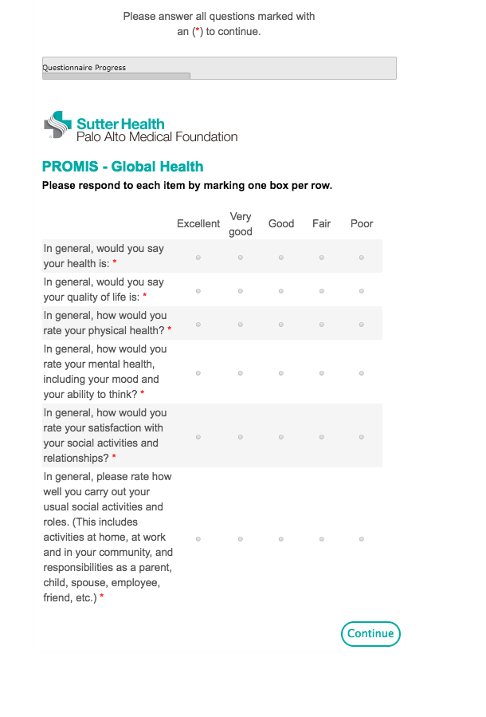

**14. PROMIS Part 2 (Q7)**

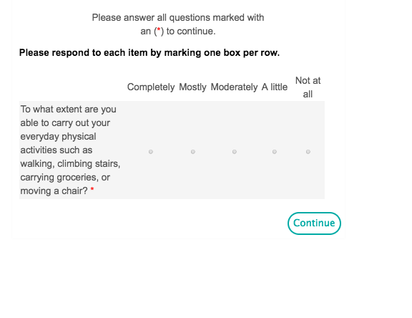

**15. PROMIS Part 3 (Q8)**

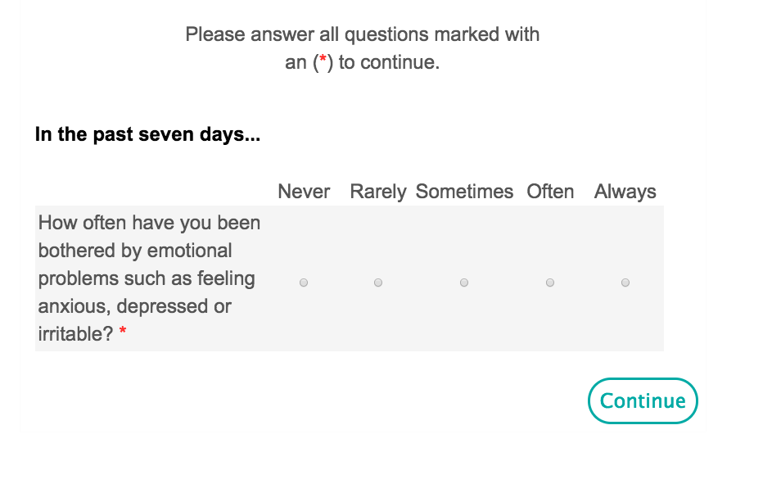

**16. PROMIS Part 4 (Q9)**

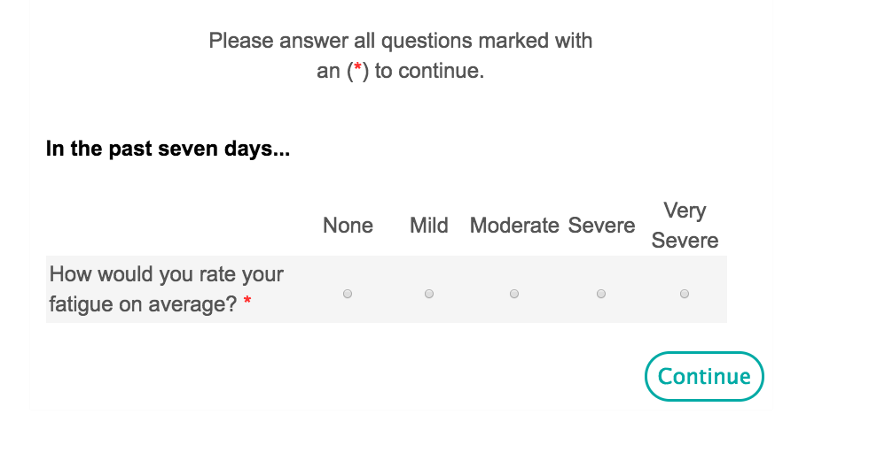

**17. PROMIS Part 5 (Q10)**

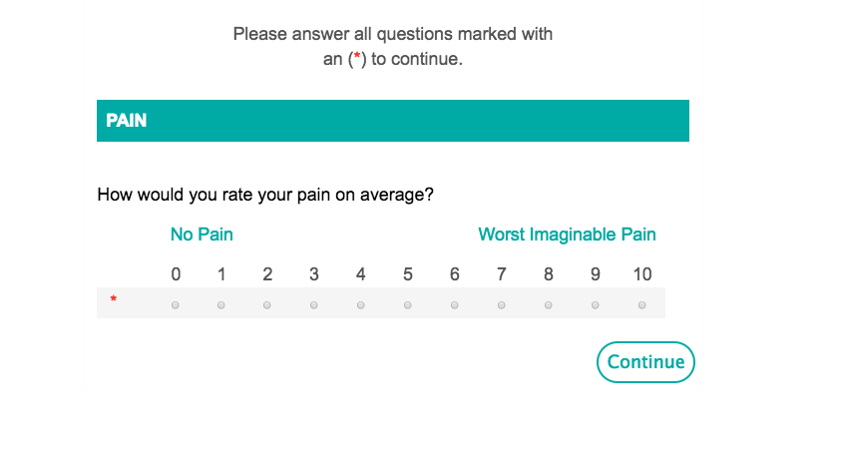

**Thank You component (for the HOOS-KOOS/PROMIS bundle)**

**18. Thank You – HIP/PROMIS Bundle**

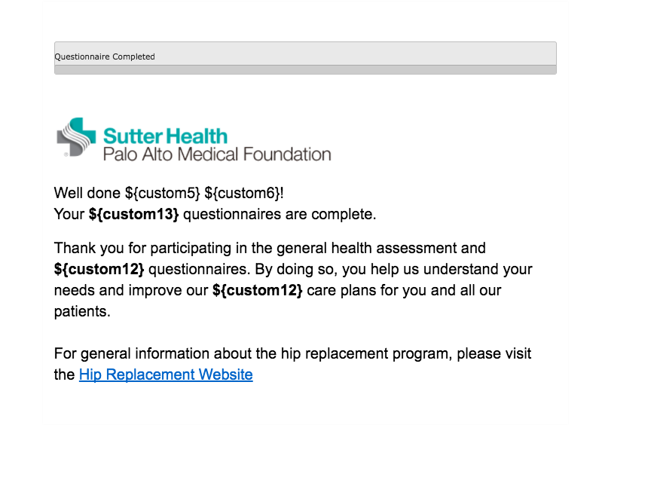

**19. Thank You – Knee (KOOS)/PROMIS Bundle**

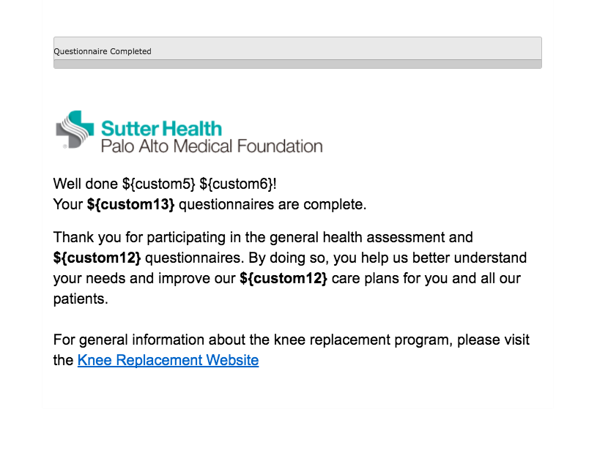

**Ineligible Patient Component**

**20. Ineligible Patient**

**To Do: Clarify when/where this is shown and to whom**

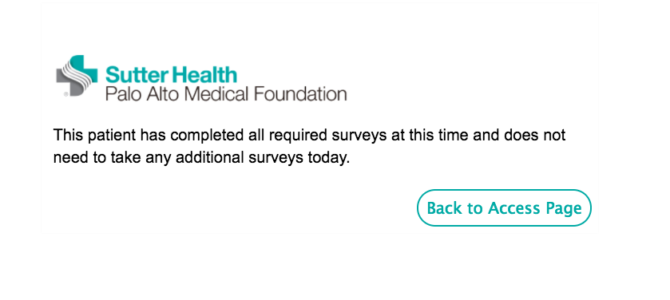

**Unsubscribe Component**

**21. Unsubscribe Confirm**

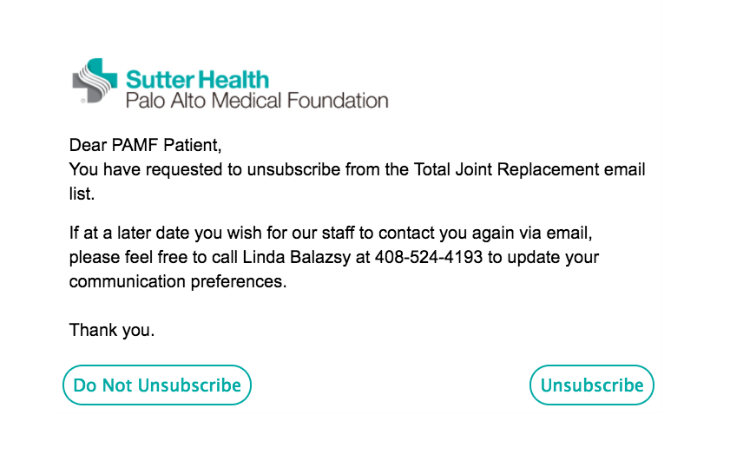

**22. Unsubscribe Thank You**

**To Do? Indicate where this goes in the flow (from what link)?**

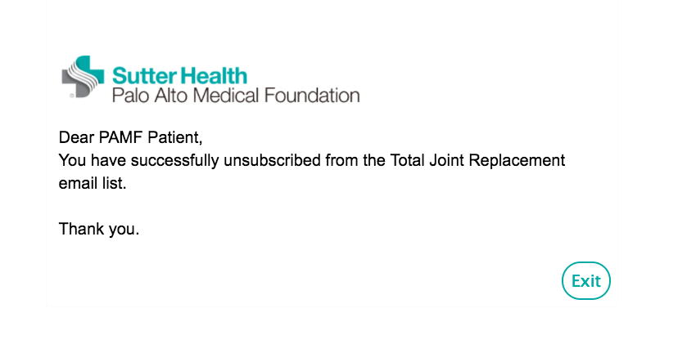

**Collaborate Questionnaire Component**

**To Do: Pull in the most recent complete page (with 3 Questions)**

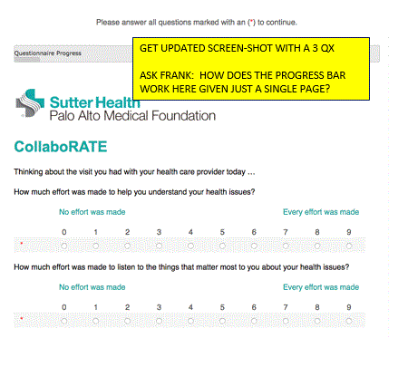

**APPENDIX:**

**Emails sent to Patients**



**Background on the PAMF PROMS Workflow**

The questionnaires are provided to a patient in a number of ways depending on the patient preference and availability of a valid email. Regardless of how the survey is provided to the patient, all surveys are captured on a computer, laptop, or mobile device.

* **In Clinic**. The questionnaire may be administered to a patient when at the clinic via one of the clinic’s iPad Tablets, if she hasn’t already completed it.
* **Email**. The questionnaire may be completed by clicking on a hyperlink in an email invite and proceeding to the landing page.
* **Letter Invites**. If a patient opts out of the email invite (or doesn’t have a valid email), a letter is sent to the patient to invite her to take the questionnaire.
  + **T**he letter offers an option to complete the survey online by going to the letter-referenced website and entering a provided survey code once there.
  + Alternatively, the patient may complete and return an enclosed paper questionnaire; the questionnaire is entered by clinical staff into the PROMS EDC using a tablet or PC.

The questionnaire bundle is sent at designated times (cycles), illustrated below, and is dictated by Maestro.

|  |  |  |  |  |  |
| --- | --- | --- | --- | --- | --- |
|  | **Cycle Period**  Invites to the Questionnaires are sent at Maestro-defined time periods | | | | |
|  | **Consult**  **(Pre-Op)** | **Post-Op 3 Month** | **Post-Op 6 Month** | **Post-Op 9 Month** | **Post-Op 12 Month** |
| **Collaborate** | Sent separately, only ONCE | NA | NA | NA | NA |
| **HOOS or**  **KOOS**  **-plus-**  **PROMIS** | Sent as a 2 Qst’nre bundle each Cycle | Sent as a 2 Qst’nre bundle each Cycle | Sent as a 2 Qst’nre bundle each Cycle | Sent as a 2 Qst’nre bundle each Cycle | Sent as a 2 Qst’nre bundle each Cycle |

The sequencing of these surveys by Cycle Period should not have a material impact on EDC Questionnaire development because the *same* questionnaires are used in each period, with slight Maestro-driven tailoring (described later) to introduce the survey to the patient, e.g., a “Consult” questionnaire for the “Left Hip”.

The questionnaire never changes across the cycle periods. However, we do tailor the intro paragraph found above Q1 in the HOOS/KOOS questionnaire to indicate the cycle period (e.g., Post-Op 3 months) and the procedure (hip or knee). We will specify how the tailoring is done in the Tech Specs.

* Patients complete the Collaborate questionnaire once, during the Pre-Op cycle. (Noted as FYI; like the HOOS-KOOS/PROMIS bundle, the number of periods sent to a patient should not impact coding costs.)
* The HOOS/KOOS and PROMIS questionnaire “bundle” and Collaborate follow this flow:
  1. An email or mail invite is sent to the patient. The PROMS app determines if it’s an email or mail send out.
     + Sutter is responsible for creating and sending both the email and mail invites
  2. Patients go to the landing page.
  3. Patients complete the questionnaire. If the bundle, they complete both HOOS or KOOS and PROMIS. If Collaborate, it’s the one questionnaire and done.
  4. We will share detail about where the patient is sent after questionnaire completion in the Tech Specs.